Regional Implementation Initiative on Preventing & Combating Human Trafficking Improving National and Transnational Coordination and Cooperation in Preventing and Combating all Forms of Human Trafficking; Developing and Strengthening National and Transnational Networks and Partnerships
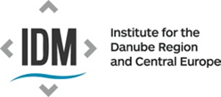

Think-tank Event
International Expert Round Table
Countering The Toxic Interface of Migration,
Human Trafficking & Related Labour Exploitation 2.0

4 October 2024, 9:00 – 16:00
'Catamaran' Johann-Böhm-Platz 1, 1020 Vienna
Austrian Trade Union Federation
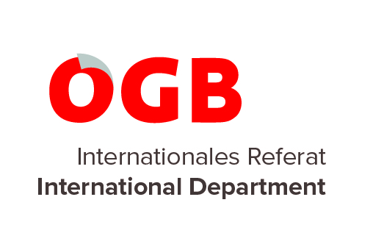
in Cooperation with
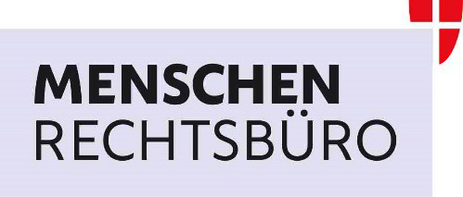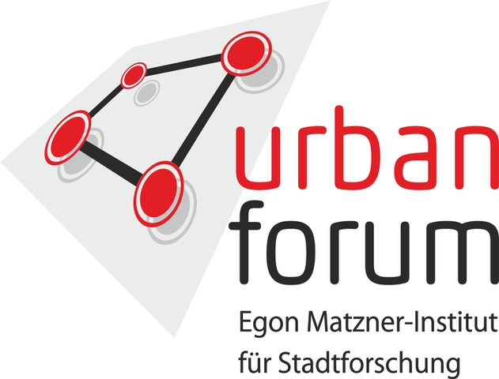
supported by
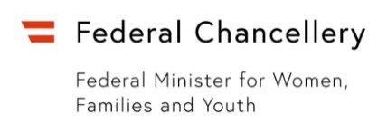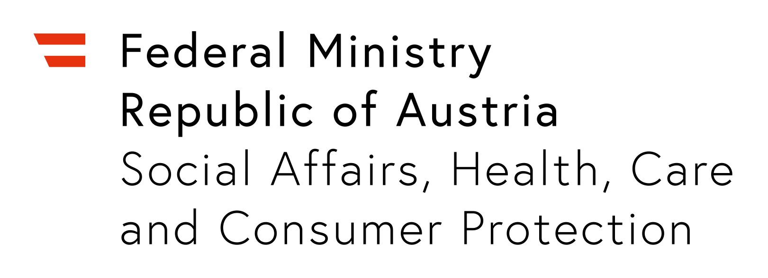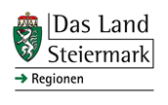

The Round Table will be held in English - No interpretation. Attending the Round Table is free of charge. Registration for ON SITE Participation is obligatory and open from 23 September - 2 October 2024 NO Registration required to access the Live stream.
Participants are invited to take note that there may be photographs taken and videos recorded for documentation purposes, a selection of which might be published on our websites and/or social media channels later on. Participants' speeches and presentations will be recorded and published on image and sound carriers as well as internet (Livestream) and television broadcast, reproduced and used audio-visually.By registering for the above Thin Tank Event/International Round Table you agree that your personal data (name, function, institution) can be automatically processed by the 'Regional Implementation Initiative on Preventing & Combating Human Trafficking’ for the indicated purpose. You may revoke your arrangement(s) any time by sending us an e-mail. If you don’t agree that your e-mail address is used for information provision and invitations on activities (Round Tables, meetings, workshops, info sessions) of the ‚Regional Implementation Initiative on Preventing & Combating Human Trafficking‘, please let us know via e-mail. We shall delete your e-mail address from the list(s).
DRAFT AGENDA
8:30 – 9.00 Registration, Networking Coffee & Snacks
9:00 – 9:45 Welcome & Opening
- Helga Konrad, Head/Coordinator 'Regional Implementation Initiative on Preventing & Combating Human Trafficking': Introduction & Moderation
Opening Remarks & Brief Comments by High-level Officials and Stakeholders on the Topic of the Think Tank : 'Countering The Toxic Interface of Migration, Human Trafficking & Related Labour Exploitation 2.0'
- Marcus Strohmeier, Head of the International Department, Austrian Trade Union Federation, Host of the Event - Johannes Rauch, Federal Government Minister, Austrian Ministry for Social Affairs, Health, Care and Consumer Protection (tbc) - Georg Stillfried, Ambassador, National Coordinator on Human Trafficking, Federal Ministry for European and International Affairs - Wolfgang Spadinger, Coordinator of the Austrian Task Force on THB, Federal Ministry for European and International Affairs - Marie-Theres Prantner, Deputy Director, Department for Women-specific Legislation & Prevention of Violence, Austrian Chancellery - Gerald Tatzgern, Police Brigade General, Head of Special Investigation, Federal Criminal Police Office, Ministry of the Interior Austria - Peter von Bethlenfalvy, Executive Director, Center for European and International Policy Action CEIPA, Brussels
9:45 - 12.15 Session I Challenging Misleading Assumptions and Stereotypes.
Migrants in general – and irregular migrants in particular – continue to be most vulnerable to exploitation and prone to being trafficked and exploited in the European Union (and beyond). Although the characteristics of human trafficking can sometimes be confused with migrant smuggling (when there is no intention to ‘exploit’ the migrant concerned), there have been many cases when these terms have been used deliberately to confuse or dupe the public. As politicians in Europe have whipped up hostility to refugees and migrants, are trafficking victims being deliberately overlooked and treated as ‘illegal immigrants’? Or are operations to stop irregular migration and deport migrants being misrepresented as well-intentioned measures to ‘save’ people from human trafficking and ‘modern slavery’? Why, almost 25 years after the 'UN Protocol on Human Trafficking' was developed, do migrants still constitute the worst treated pool of cheap labour, with many forced to work? Why are they endlessly found working or living in unacceptable conditions, without health care or social insurance, and underpaid or with their wages withheld by brokers? Are the measures prescribed by anti-trafficking treaties to prevent human trafficking inadequate? Has it been helpful to equate human trafficking and irregular migration with organized crime and to expect the criminal justice system to provide solutions? What is it about the legal systems and labour markets in Europe that has created so many loopholes for criminals to exploit? Panellists will challenge and scrutinze current approaches and models of ‘migration management’, which focus primarily on preventing irregular migration by stepping up border controls, and provide in-depth insights into current reality of the interface between human trafficking, smuggling and migration, - suggesting possible solutions.
9: 9:45 – 10:00 Deals, Deals, Deals... – are we Tackling the Right Problems?
Observations by - Günther Ogris, Social Researcher, Pollster, Austria - Beatrix Attinger, Independent Expert, former OSCE Organization for Security and Cooperation in Europe, former UN Senior Expert
10:00 – 11:15 Expert Panel Discussion 1
- Libya – a Case Study on the Role of Trafficking Groups in European Migration Governance - Luigi Achilli, Senior Researcher, Migration Policy Centre, Chr. Michelsen Institute, Italy/Norway
- Spain: Challenges & Contradictions in the Management of the Western African and Western Mediterranean Migratory Routes - Markus Gonzalez Beilfuss, Professor of Constitutional Law at Barcelona University, former Understatesecretary of the Spanish Ministry of Universities, Spain
- To Punish, or Not To Punish? That's the Question - Conny Rijken, Researcher, Univ.Prof. Tilburg University, National Rapporteur NL
- Putting all one's Eggs in the Basket of Criminal Law Enforcement simply does not Work - Roger Plant, Independent Expert, UK, former Head of ILO - International Labour Organization Special Action Programme to Combat Forced Labour
Q&A
11:15- 12:15 Expert Panel Discussion 2:
- As long as People in Precarious Situations have 'NO OTHER CHOICE BUT', all Anti-trafficking Measures and Policies will Continue to Fail. - Kiril Sharapov, Researcher, Professor of Applied Social Sciences, Edinburgh Napier University, Scotland
- Refugees and Forcibly Displaced People are Particularly at Risk of Being Trafficked - Liliana Sorrentino, Legal Officer, Division of International Protection, UNHCR - United Nations High Commissioner for Refugees (tbc)
- Precondition for Change: Addressing the Structural Causes of Labour Trafficking: Why this Alternative and Advice on Protecting Migrant Workers are so often Ignored - Mike Dottridge, Independant Expert, UK
- How will the EC Anti-Trafficking Unit Ensure that Migration Policies do not Contribute to or Exacerbate Human Trafficking? - NN, (tbc)
Q&A
12.15 - 13.00 Networking Break
13.00 - 16.00 Session II Ensuring that Everyone who is Trafficked Gets Attention & the Right Protection
Who among the migrants that are trafficked ‘slips through the net’ and does not get appropriate protection? Have we learned the lessons or is more monitoring and research needed to understand the factors contributing to ‘trafficking for the purpose of labour exploitation’ for each group? What further measures need to be given priority? Last but not least, are there examples of coordinated responses involving both state authorities and civil society that should be regarded as 'good practice'? Panellists will review the particular predicament of migrant women, men and children and the effectiveness of measures intended to stop them being trafficked and exploited.
13:00 – 14:00 Expert Panel Discussion 3: Magnifying Glass on Women:
- The Violence you can’t see: Violence against Migrant Women and Human Trafficking - Zoi Sakelliadou, Crime Prevention & Criminal Justice Officer, UNODC - United Nations Office on Drugs and Crime, Human Trafficking and Migrant Smuggling Section Findings of UNODC Global Reports on Trafficking in Persons
- Knowing Your Rights is NOT Enough - Katarzyna Winiecka, Managing Director, UNDOK - Drop-in Centre for (Union) Support for Undocumented Migrant Workers, Austria
- Participation, Power, Identity: Inclusion of Former Affected Persons in Anti-Trafficking Responses - Sangeetha Manavalan-Thoppil, Head, Intervention Centre for Trafficked Women and Girls, LEFÖ-IBF, Austria
- There is an Urgent Need for a Progressive Interpretation & Evolution of the Strategical Use of International Human Rights Law and Frameworks - Madeleine Rees, Independent Expert, former OHCHR - UN Human Rights Office, and former President of WILPF Women's Internatinal League for Peace and Freedom, Geneva
Q&A
14:00 – 15:00 Expert Panel Discussion 4: Men Victms in Focus:
- All Forms of Underpayment, Social Dumping and Labor Law Violations Must Rigorously be Fought against and Severely Punished - Markus Zingerle, Sociologist, MEN VIA - Support for Male Victims of Human Trafficking, Vienna 10 Years of Experience in Working with Male Victims of Trafficking & Exploitation
- Legalizing Irregular Workers in Greece – an Update - Vassilis Kerasiotis, Lawyer, Government Consultant, Greece
- The Danish Experience – Criminal & Labour Exploitation of Migrant Men from African Countries - Michele Mildwater, Trauma Therapist, Founder & Director of NGO HopeNow, DK
- Only Access to Labour Rights and Remedies for ALL Workers will Effectively Reduce Human Trafficking - Suzanne Hoff, International Coordinator, NGO Network La Strada International, NL
- It all Starts with the Recruitment - Philipp Schwertmann, Head of Migration and Decent Work Section at 'Arbeit & Leben', Trade Union/VHS Adult Education Center, Berlin
Q&A
15:00 – 16:00 Expert Panel Discussion 5: Children and Minors at Risk
Children represent a significant proportion of trafficking victims worldwide. They are twice as likely to face manyfold violence and exploitation than adults during migartion and refugee flows, according to the UNODC Global Reports. Furthermore the proliferation of online platforms poses additional risks for children as they often connect to these sites without adequate safeguards.Traffickers and other criminals browse online platforms, social media and the so-called dark web to recruit and exploit children, utilizing technology to reach wider audiences to disseminate exploitative content – and to evade detection. Panelists will provide in-depth insight into the most recent developments and challenges, and what is needed to more effectively prevent and combat child trafficking and exploitation, by paying special attention to children on the move.
- Challenging Assumptions in the Field of online Child Trafficking and Sexual Exploitation - Financial Sextortion of Children as a Business Model - Helmut Sax, Senior Researcher, Ludwig Boltzmann Institute of Fundamental and Human Rights, Austria
- Children on the Move, New Victims of Organized Crime – Olivier Peyroux, SciencesPo Paris, President of the Association 'Koutcha', France
- Underaged Forced Marriages - Katharina Beclin, Assistant Professor, University of Vienna
- More of the same? Questions Deriving from Inclusion of Forced Marriage, Illegal Adoption and Illegal Surrogacy as New Forms of Exploitation in the EU Directive 2024/1712 - Astrid Winkler, ECPAT Austria & International Independent Expert & Trainer, Prevention of Sexual Exploitation of Children, Safeguarding & Measures against Child Trafficking
- Moving Forward: From a Child Protection to a Rights-based Interagency Approach - Daja Wenke, Independent Researcher and Policy Analyst, Rights of the Child - Implementation of International Standards, Italy/Germany
Q&A
Concluding Remarks
16:00 Close of the Event

The entire event will be streamed live.
In preparation of the Think Tank Event, you are invited to consult our PlatformNET under https://thbregionalimplementationinitiative.wordpress.com for abstracts of the experts and panelists, as well as background information and additional documents and links.
How to reach the conference venue:
Take the underground U1 from Stephansplatz, direction Leopoldau until Praterstern (3 minutes); change and take the U2, direction Seestadt until Donaumarina (6 minutes); exit and walk towards Johann-Böhmplatz 1/ÖGB Catamaran (2 minutes)

